H.T No
Regulations:
A22

Sreenidhi Institute of Science and Technology
(An Autonomous Institution)
Code No: 9BC01 Date: 14-Feb-2025 (FN)

B.Tech I-Year II- Semester External Examination, Feb-2025 (Supplementary)
ENGINEERING GRAPHICS(CSE, IT, CS, AIML, DS & IOT)

Time: 3 Hours Max.Marks:60

Note: a) No additional answer sheets will be provided.
b) All sub-parts of a question must be answered at one place only, otherwise it will not be valued.
c) Missing data can be assumed suitably.
Bloom's Cognitive Levels of Learning (BCLL)

Remember | L1 | Apply | L3 | Evaluate | L5
Understand | L2 | Analyze | L4 | Create | L6

Part - A Max.Marks: 6x2=12

Answer all QUESTIONS, EACH QUESTION CARRIES 2 MARKS.

 |  | BCLL | CO(s) | Marks
1 | What are the applications of Ellipse | L1 | CO1 | [2M]
2 | What is the difference between First angle Projection and Third angle Projection? | L2 | CO2 | [2M]
3 | Explain the planes of Projection | L1 | CO3 | [2M]
4 | What is the difference between a Prism and a Pyramid? | L1 | CO4 | [2M]
5 | What is isometric view | L2 | CO5 | [2M]
6 | What is the difference between isometric view and isometric protection? | L2 | CO6 | [2M]

Part – B Max.Marks: 6x8=48
ANSWER ALL QUESTIONS. EACH QUESTION CARRIES 8 MARKS.

 |  |  | BCLL | CO(s) | Marks
7. |  | Construct a hyperbola if the A fixed point is at distance of 60mm from fixed straight line trace the path of curve if eccentricity is 3/2. Also draw a tangent and normal to it at 55 mm from the directrix | L1 | CO1 | [8M]
 |  | OR
8 |  | A circle of 40 mm diameter rolls on another circle of diameter is 100 mm rolling outside, name the curve. Also draw tangent and normal to it. | L3 | CO1 | [8M]
9. |  | The top view of 75 mm long line measures 65 mm while it's front view measures 55 mm. Draw the projections of the straight line when one of the end is 25 mm above HP and 30 mm in front of VP. | L3 | CO2 | [8M]
 |  | OR
10 |  | The line AB is 70mm long and is inclined at 30º to HP and 45º VP. It's one end is 10 mm above HP and 15 mm in front of VP. Draw its protections. | L3 | CO2 | [8M]
11. |  | A Hexagonal Plane of side 30mm is inclined to HP at 30° and its surface is inclined to VP at 45°. Draw its Projections draw its projections when one of the side is perpendicular to HP. | L2 | CO3 | [8M]
 |  | OR
12 |  | A Hexagonal pyramid of base side 30 mm and axis length 65 mm has its axis is inclined to V.P at 45° draw its projections. | L2 | CO3 | [8M]
13. |  | A cone, diameter of base 50 mm and axis 50 mm long is resting on its base on the H.P. It is cut by a section plane perpendicular to the V.P., inclined at 75° to the H.P. and passing through the apex. Draw its front view, sectional top view and true shape of the section. | L4 | CO4 | [8M]
 |  | OR
14 |  | Draw the development of a cone of diameter 40mm axis length 65mm is sectioned by a plane inclined at 35° to HP and passing through midpoint of the axis of the cone. | L3 | CO4 | [8M]
15. |  | Draw the isometric view of a cone of base diameter 40mm axis length 60 mm | L4 | CO5 | [8M]
 |  | OR
16 |  | Draw the isometric view of a square pyramid of base side 40mm and axis length 60 mm when the axis is horizontal. | L4 | CO5 | [8M]
17. |  | Draw the Front view Top view and side view for the following figure  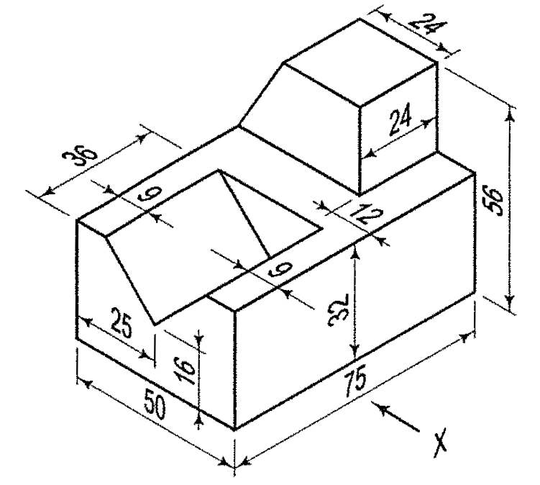 | L4 | CO6 | [8M]
 |  | OR
18 |  | Draw the Front view Top view and side view for the following figure  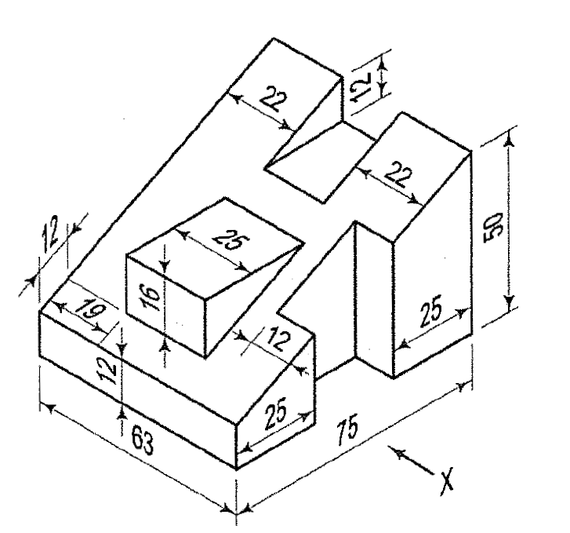 | L4 | CO6 | [8M]

-- 00 -- 00 –

